Chapter 5, Solution 50.

(a) We use a difference amplifier, as shown below:
−+
+
v_{o}
R₂
v₁
R₁
R₂
v₂
R₁

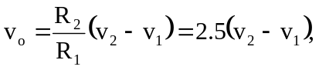 i.e. R₂/R₁ = 2.5
If R₁ = 100 kΩ then R₂ = 250kΩ

(b) We may apply the idea in Prob. 5.35.

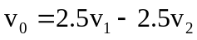
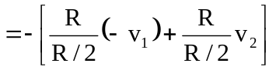
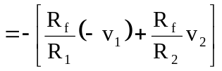

i.e. R_{f} = R, R₁ = R/2.5 = R₂

We need an inverter to invert v₁ and a summer, as shown below. We may let R = 100 kΩ.
−+
+
R
-v₁
v₁
R
−+
+
R
v_{o}
v₂
R/2.5
R/2.5

